ONLINE LEARNING PLATFORM USING MERN

1. Introduction

Project Title: Online Learning Platform Using MERN

TEAM MEMBERS:

|  |  |  |  |
| --- | --- | --- | --- |
| S.NO | NAME | ROLE | RESPONSIBILITIES |
| 1. | Arunkumar B | Full-Stack  Developer | Responsible for overall development,  Including front-end, back-end, server-side logic, and database design |
| 2. | Balaabirami B | Frontend  Developer | Responsible for UI/UX design using React, Material UI, and Bootstrap. |
| 3. | Aruna Devi G | Backend Developer | Responsible for Express.js setup and API development. |
| 4. | Aarigopal | Database  Administrator | Responsible for MongoDB setup and ensuring data integrity. |

2. Project Overview

Purpose: The Online Learning Platform will be a web-based application designed to facilitate online learning by providing an intuitive and then interactive environment for students and instructors. The platform will support various features such as course creation, video lectures, quizzes, and student progress tracking. By leveraging the ****MERN stack (MongoDB, Express.js, React.js, Node.js)****, the platform will be capable of handling dynamic content, real-time updates, and a wide range of functionalities, ensuring that the platform is both scalable and easy to maintain.

Features:

* **Authentication & Authorization**:
* User login/signup with JWT tokens for secure sessions.
* Different access levels for students, instructors, and admins.
* **Course Management**:
* **Course creation:** Add title, description, video lectures, quizzes, etc.
* Categorization of courses.
* Enroll/un-enroll in courses.
* **Quiz and Assignment System**:
* Create multiple-choice quizzes, assignments, and coding challenges.
* Auto-grading and feedback for quizzes.
* **Video Playback**:
* Stream video lectures within the platform.
* Video pause, resume, and tracking progress (watch time).
* **Notifications**:
* Email or in-app notifications for course updates, new lectures, assignments, and grades.
* **Additional Features:**
* **Peer Reviews**: Students can review each other’s assignments.
* **Real-time Chat**: Live messaging between students and instructors.

2. Architecture

Frontend:

* Design a clean, intuitive, and responsive interface for easy navigation on any device.
* Components like **Home**, **Course Listings**, **Course Details**, **Student Dashboard**, **Instructor Dashboard**, and **Admin Panel**.
* Client-side state management using **Redux** to handle course enrollment, user data, and UI state.

Backend:

* ****Node.js****: Server-side JavaScript runtime.
* RESTful API routes for managing courses, users, quizzes, and payment integration.
* JWT-based authentication for role-based access (Student, Instructor, Admin).
* Real-time chat and notifications with Socket.io.

Database:

* The application uses MongoDB, a NoSQL database, to store and manage the data. MongoDB is chosen for its flexibility and scalability.
* **MongoDB**: NoSQL database for storing user data, courses, quizzes, progress, etc.
* **Mongoose**: ODM (Object Data Modeling) library for MongoDB to simplify interaction with the database.

Prerequisites:

* Node.js: Make sure Node.js is installed. This is needed to run the application locally and install necessary dependencies.
* MongoDB: Ensure that you have a running instance of MongoDB. You can use either a local MongoDB setup or a cloud-based solution like MongoDB Atlas.
* npm: The Node Package Manager (npm) is required to install dependencies.

**Payment Integration**:

* Integration with **Stripe** or **PayPal** for subscription or pay-per-course models.
* Revenue management for instructors and platform commission.

4. Setup Instructions

Prerequisites:

* **Node.js**: Download Node.js.
* **MongoDB** (local or cloud): Install MongoDB locally or use [MongoDB Atlas](https://www.mongodb.com/cloud/atlas).
* **Git**: [Download Git](https://git-scm.com/downloads) to manage source control.
* **Text Editor**: Use VS Code or any code editor you're comfortable with..

Installation:

### ****Clone the Repository:****

git clone <https://github.com/yourusername/online-learning->platform-mern.git

cd online-learning-platform-mern.

* 1. **Frontend Installation:** Navigate to the client folder and run:

cd client

npm install

* 1. Install Backend Dependencies: Navigate to the server folder and run:

cd server

npm install

* 1. Set up Environment Variables: Both the **backend** and **frontend** need environment variables to configure the project.
  2. **MONGO_URI**: Use the **local MongoDB URI** or get the **MongoDB Atlas URI** from your Atlas dashboard.
  3. Start the Backend Server: Run the following command in the server directory:

npm start

* 1. Start the Frontend Server: Run the following command in the client directory:

npm start

This will point the frontend to your backend API running on localhost:5173.

5. Folder Structure

Client:

* + The **React frontend** of the **Online Learning Platform** is structured to keep components modular, organized, and maintainable.
  + Built with **React** to provide the user interface, routing and state management.
  + src/: The heart of the React application where all JavaScript/JSX, CSS, and assets live.
  + Header.js: Contains the top navigation bar (logo, login/signup links, etc.).
  + Footer.js: Contains the footer section (e.g., links to terms of service, privacy policy).
  + courseCard.js: Displays course info in a card format, used on the homepage or course listings

Server:

* + config/: Holds configuration files like database connection, JWT authentication setup, and third-party integrations (e.g., Stripe).
  + controllers/: Contains functions that handle the business logic for various routes (user login, course management, payment processing).
  + middleware/: Includes Express middleware for tasks like user authentication (authMiddleware.js) and error handling (errorMiddleware.js).
  + routes/: Defines the route handlers that connect to controllers (e.g., authRoutes.js for authentication routes).
  + utils/: Contains utility functions, like logging or helper functions that don’t fit in other folders.

6. Running the Application

Frontend: To start the frontend server, run the following command in the client folder:

npm start

Backend: To start the backend server, run the following command in the server folder:

npm start

7. API Documentation

1. POST /api/auth/register: Register a new user (either a student or admin)

Request Body:

json

Copy code

{

"email": "user@example.com",

"password": "password123",

"name": "John Doe",

"role": "student/admin"

}

Response:

json

Copy code

{

"message": "Registration successful"

}

2. POST /api/auth/login: Authenticate a user (student/admin) and receive a JWT token

Request Body:

json

Copy code

{

"email": "user@example.com",

"password": "password123"

}

Response:

json

Copy code

{

"token": "jwt_token_here"

}

3. GET /api/courses: Fetch a list of available courses

Response:

json

Copy code

[

{

"id": 1,

"title": "Introduction to Python",

"instructor": "Dr. John Doe",

"duration": "4 weeks",

"price": "Free"

},

{

"id": 2,

"title": "Advanced Data Science",

"instructor": "Dr. Jane Smith",

"duration": "8 weeks",

"price": "$100"

}

]

4. POST /api/courses/enroll: Enroll a user (student) in a selected course

Request Body:

json

Copy code

{

"courseId": 1,

"enrollmentDate": "2024-12-01T10:00:00Z"

}

Response:

json

Copy code

{

"message": "Successfully enrolled in course",

"enrollmentId": "12345"

}

5. POST /api/admin/login: Admin login and receive a JWT token

Request Body:

json

Copy code

{

"email": "admin@example.com",

"password": "adminpassword123"

}

Response:

json

Copy code

{

"token": "admin_jwt_token_here"

}

6. GET /api/admin/courses: Fetch a list of courses for the admin (for course management)

Response:

json

Copy code

[

{

"id": 1,

"title": "Introduction to Python",

"instructor": "Dr. John Doe",

"duration": "4 weeks",

"price": "Free"

},

{

"id": 2,

"title": "Advanced Data Science",

"instructor": "Dr. Jane Smith",

"duration": "8 weeks",

"price": "$100"

}

]

7. POST /api/admin/courses/create: Admin creates a new course

Request Body:

json

Copy code

{

"title": "Introduction to Machine Learning",

"instructor": "Dr. Emma Brown",

"duration": "6 weeks",

"price": "$150"

}

Response:

json

Copy code

{

"message": "Course created successfully",

"courseId": "67890"

}

8. Authentication

JWT Authentication is a critical aspect of any web application, especially for managing user access to protected routes and data. In this **MERN stack (MongoDB, Express, React, Node.js)** application and routes, **JWT (JSON Web Tokens)** can be used to manage authentication. Here's a breakdown of how to implement authentication in both the **backend (Node.js + Express)** and **frontend (React)**.

Authorization Middleware:

* Authentication Middleware: A **uthentication** in the **Online Learning Platform** is handled using **JWT (JSON Web Tokens)**, which securely verifies user identity. When a user registers, their credentials (name, email, password) are stored in MongoDB, with the password securely hashed using **bcrypt**.
* This token is sent to the frontend and stored in ****localStorage**** to maintain the user's session. For every subsequent request to protected routes, the frontend sends the JWT in the ****Authorization header****, allowing the backend to verify the user's identity.
* Authorization Middleware: **Authorization** in the **Online Learning Platform** refers to determining what actions or resources a user is allowed to access after they have been authenticated. While **authentication** verifies the user's identity, **authorization** controls their access to specific parts of the platform based on their roles, permissions, or other criteria.
* Once a user logs in and is authenticated, their role (e.g., student, instructor, or admin) is stored in the **JWT (JSON Web Token)**, allowing the backend to verify their access to specific routes and functionalities.

9. User Interface

The **User Interface (UI)** of the **Online Learning Platform** built with the **MERN stack** is designed to be intuitive, responsive, and user-friendly, providing both learners and instructors with an easy-to-navigate experience.

Login Page:

* ****Login Page****: Users can enter their credentials (email and password) to log in. It includes validation for correct input and error messages (e.g., "Invalid email or password"). A "Forgot Password" link is also provided for account recovery.

Dashboard (Customer):

* **Student Dashboard**: Upon logging in, students are directed to their personal dashboard, which displays:
* A list of available courses they are enrolled in.
* Progress tracking (e.g., completion percentage or upcoming lessons).

**Course Pages:**

* **Course Overview**: Each course has a dedicated page showing an overview of the course content, including course description, syllabus, instructor details, and enrollment options. Students can view lessons, videos, and other course materials.

**Admin and Instructor Tools:**

* Instructors can create courses by adding lessons, video content, quizzes, and assignments through a user-friendly form.
* The course creation page includes options for structuring the course, adding metadata (e.g., course title, description, prerequisites), and publishing.

The **Online Learning Platform’s UI** is designed to provide an engaging, intuitive, and accessible experience for users across different devices. With clear navigation, responsive design, interactive learning tools, and role-specific interfaces (student, instructor, admin), the platform ensures that users can easily manage their learning journey, interact with peers and instructors, and track their progress.

10. Testing

Testing Strategy:

Testing is crucial to ensure that the **Online Learning Platform** built with the **MERN stack (MongoDB, Express, React, Node.js)** functions as expected, is reliable, and provides a seamless user experience. The goal is to catch bugs early, ensure high-quality code, and validate that the platform meets both functional and non-functional requirements.

Unit Testing:

* + - The test individual components, functions, or methods in isolation to ensure they behave as expected.
    - This covers testing individual backend routes, frontend components, and utility functions.

Integration Testing:

* The test the interaction between different parts of the system, such as between the frontend and backend or between the database and API.
* This includes testing full API endpoints, ensuring that data flows correctly between the server, database, and frontend

End-to-End Testing:

* To simulate real user interactions with the platform to ensure the entire application works as expected from the user’s perspective.
* Testing user flows, such as registration, login, course enrollment, and course content access, across both the frontend and backend.

Testing Tools:

****Supertest****: For testing HTTP requests to the Express API, Supertest is used to make requests and assert the expected response.

****Jest****: Used for integration tests as well, to test how different parts of the application work together.

11. Screenshots

Landing page:

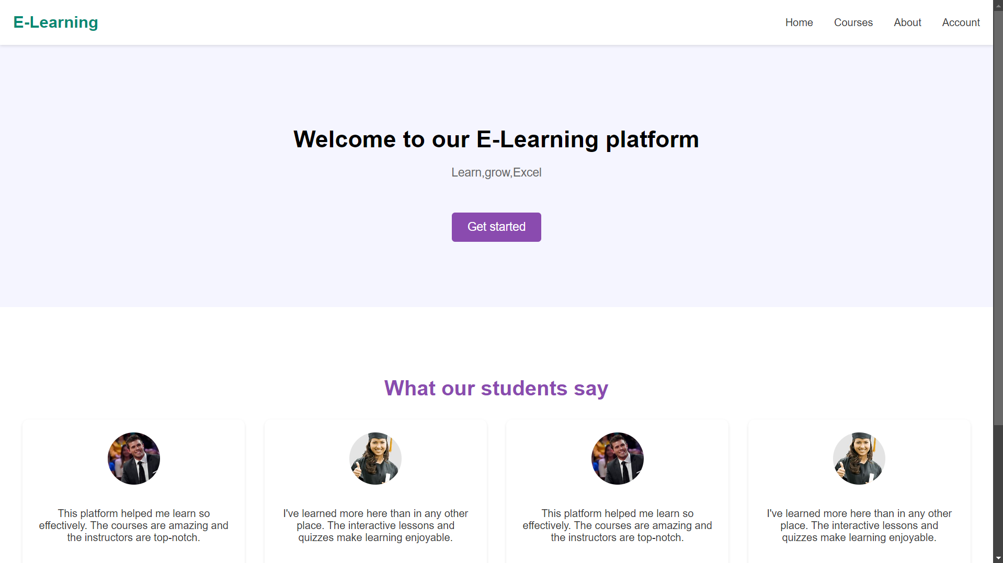

Register page:

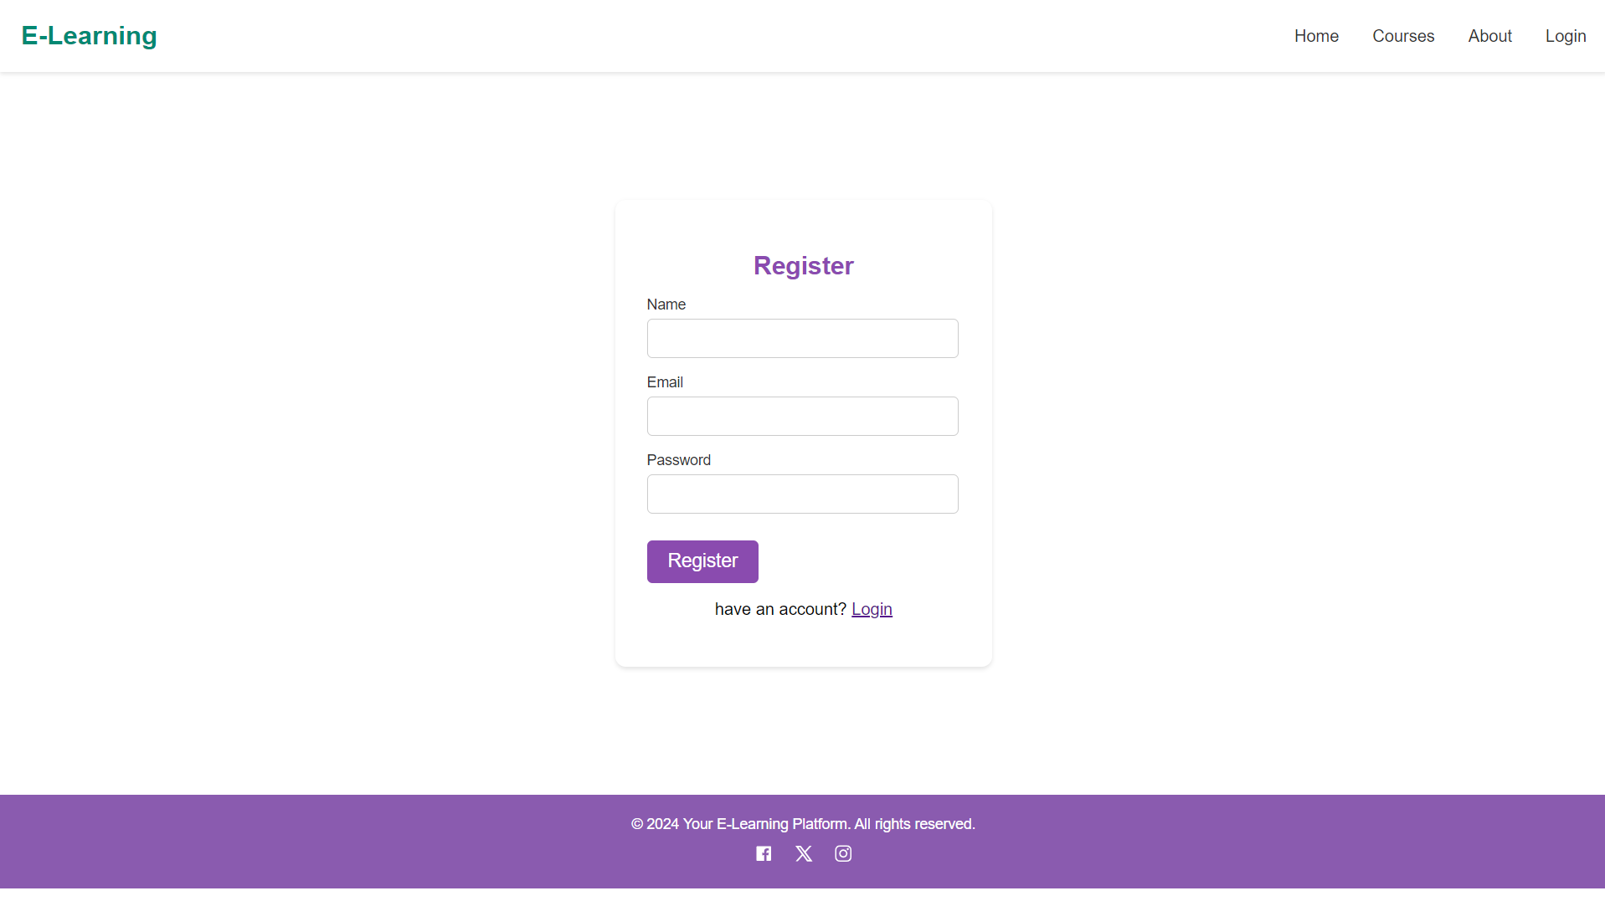

User Profile:

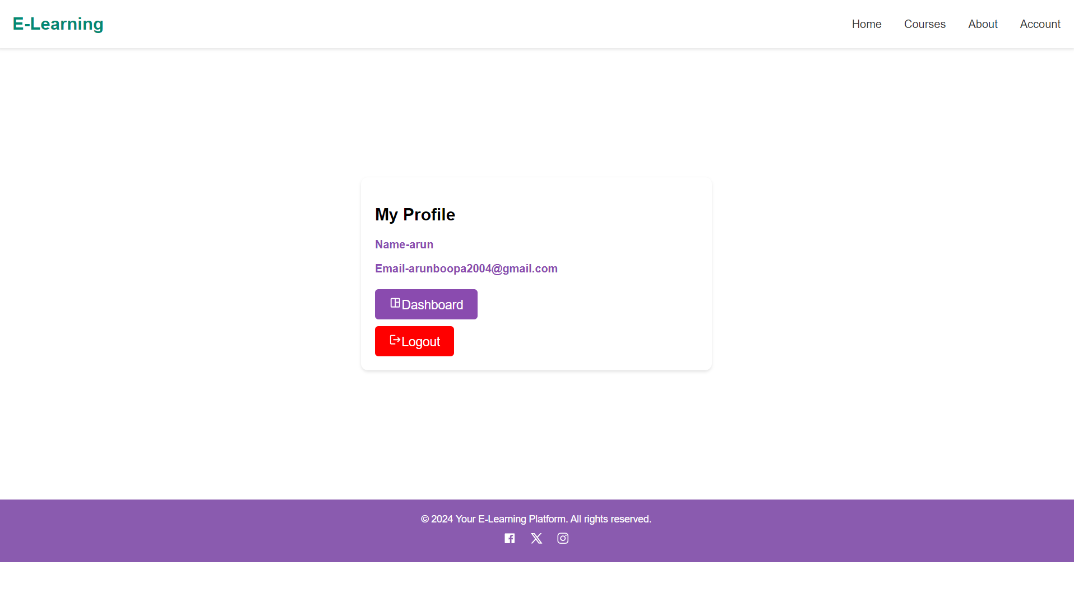

Course Page:

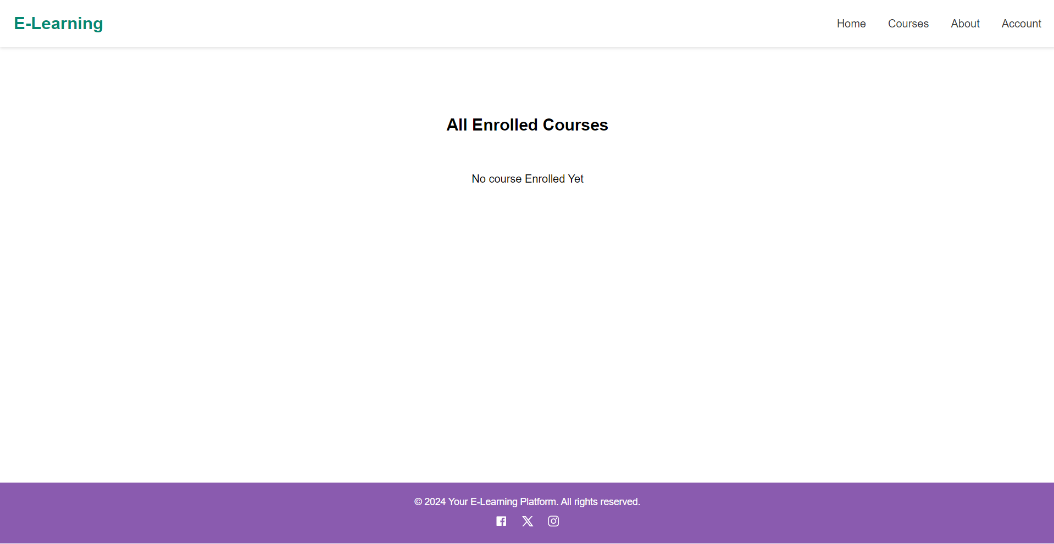

12. Known Issues

While most of the application is fully functional, there are a few issues that developers or users should be aware of:

* ****Cross-Browser Compatibility****: Some issues with older browsers like Internet Explorer and Safari causing layout or functionality problems.
* ****Mobile Responsiveness****: Course pages may not display correctly on small screens, particularly with embedded videos.
* ****Token Expiration****: JWT tokens may expire too quickly, logging users out unexpectedly.
* ****Authentication Token Expiration****: JWT tokens may expire too quickly, logging users out unexpectedly.

****Workaround****:

* Users can try refreshing the page or clearing the browser cache.
* Developers are recommended to optimize assets like images, videos, and CSS files for faster loading times.

These are some of the **known **issues**** that users and developers should be aware of while using or developing the **Online Learning Platform**.While most of these issues are being actively addressed by the development team.The development team is committed to ensuring a high-quality, bug-free user experience and is continuously working to resolve these issues. Regular updates and bug fixes will be released to improve platform stability and performance.

13. Future Enhancements

****Real-Time Notifications****: Implement **WebSockets** or **server-sent events** to provide real-time notifications for messages, updates,and then course activities to improve user engagement.

**AI-Powered Recommendations**: Introduce **AI-driven course recommendations** based on user activity, interests, and progress to personalize the learning experience and keep users engaged.

**Gamification**: Implement **leaderboards, badges**, and **rewards** to make learning more interactive and motivating, especially for students in large online courses.

**Multilingual Support**: Add **language localization** to make the platform accessible to a global audience, allowing users to learn in their preferred language.

**Enhanced Video Streaming**: Improve **video compression** and implement **adaptive bitrate streaming** for smoother playback, especially in low-bandwidth scenarios.

**Improved Course Creation Tools**: Enhance the **instructor dashboard** with more powerful tools for managing content, creating quizzes, and analyzing student performance.

**Live Classes and Webinars**: Integrate **live video streaming** capabilities for real-time teaching, webinars, and interactive sessions with instructors and students.